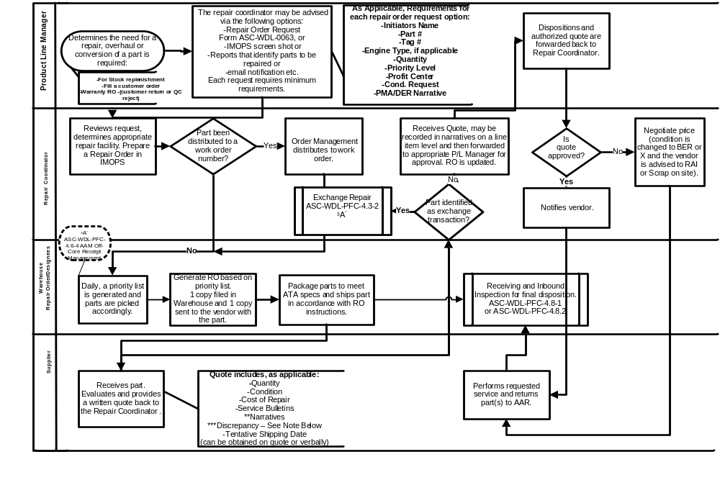

NOTE: ***Discrepancy - 1. Wrong/Different Part Number:
- Discrepancy report give to QC
- IMOPS updated – if possible
- Report placed with R.O. file

